Look at this map of Wales.
Look in an atlas and mark in some of the main places in Wales, show where you live.
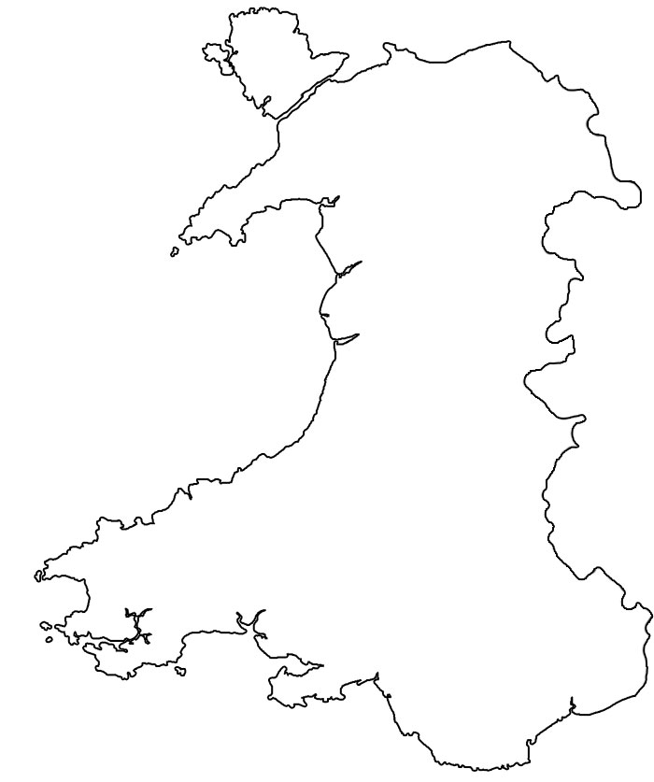

Find out about one of the places you have marked on the map and write a description giving some of its main features.
____________________________________________________________________________________________________________________________________________________________________________________________________________________________________________________________________________________________________________________________________

